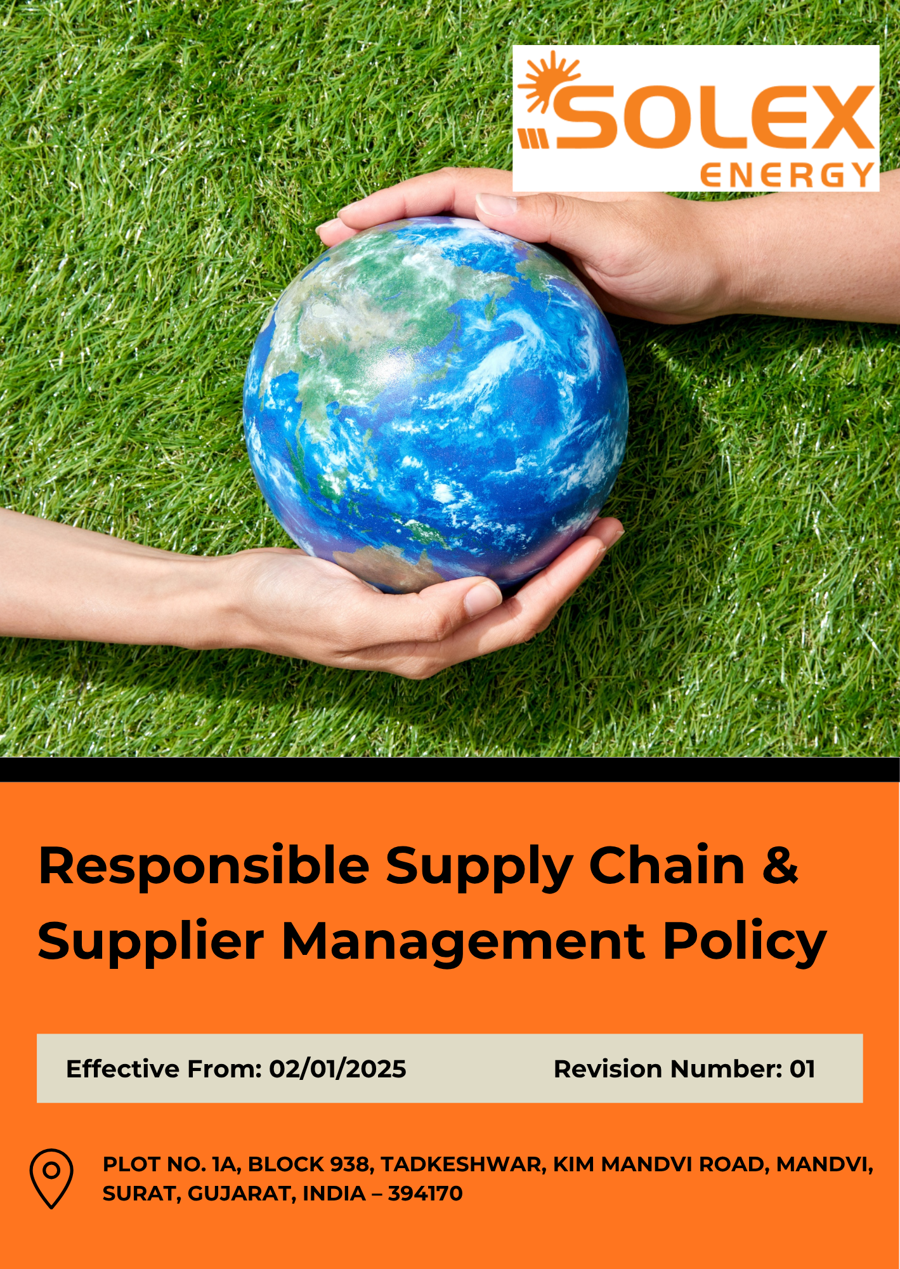
INDEX

1. Purpose & Policy Statement 3
2. Scope 3
3. Responsible Supply Chain & Supplier Management Priority Areas 3
4. Supplier Recognition & Performance Excellence 4
5. Our Strategic Goals and Commitments 5
6. Our Measurable Targets 7
7. General Targets 8
9. Contribution to the Sustainable Development Goals (SDGs) 9
10. Governance 9
11. Performance Reporting 12
12. Review Mechanism 13
13. Employee Acknowledgement 14

1. Purpose & Policy Statement
Solex Energy Limited is committed to maintaining a responsible, ethical, and transparent supply chain. The Company seeks to integrate environmental, social, ethical, and governance considerations into its supplier selection, evaluation, and management processes.
The Company expects its suppliers, contractors, and business partners to comply with applicable laws and regulations, uphold ethical business practices, respect human rights, provide safe working conditions, and minimize environmental impacts. Through responsible supplier management, due diligence, and ongoing engagement, Solex Energy Limited aims to promote sustainable business practices and strengthen the resilience and integrity of its supply chain.

2. Scope
This Policy applies to all employees of Solex Energy Limited involved in procurement, purchasing, sourcing, vendor selection, supplier management, and related activities.
Where applicable, the Policy also extends to suppliers, contractors, service providers, and other business partners engaged with the Company. It covers responsible supplier selection, evaluation, purchasing decisions, supplier engagement, ethical business practices, environmental considerations, human rights, labor standards, and compliance with applicable laws and Company requirements.
Solex Energy Limited | Block No. 938, Plot No. 1A, Tadkeshwar, Taluka Mandvi, Kim–Mandvi Road, District Surat, Gujarat – 394170, India

3. Responsible Supply Chain & Supplier Management Priority Areas
Solex Energy Limited is committed to responsible supplier management and expects employees involved in procurement and supplier-related activities to consider ethical, environmental, social, and compliance factors in business decisions. The following areas are considered relevant to the Company's supply chain:
- Responsible Supplier Selection & Due Diligence: Suppliers are selected, evaluated, and onboarded through fair, transparent, and risk-based processes that consider quality, technical capability, commercial suitability, legal compliance, and relevant environmental, social, and governance (ESG) factors.
- Environmental Responsibility: Suppliers are encouraged to comply with applicable environmental requirements and adopt practices that support resource efficiency, pollution prevention, waste reduction, and responsible environmental management throughout the supply chain.
- Labour, Human Rights & Health and Safety: Suppliers and contractors are expected to uphold applicable labour and human rights standards, provide safe and healthy working conditions, prohibit child and forced labour, and promote fair treatment, non-discrimination, and worker dignity.
- Ethical & Legal Compliance: Employees and suppliers are expected to conduct business with integrity, transparency, and accountability while complying with applicable laws and regulations. Bribery, corruption, fraud, collusion, and conflicts of interest are prohibited.

4. Supplier Recognition & Performance Excellence
Solex Energy Limited may recognize high-performing suppliers that demonstrate excellence in quality, delivery, compliance, sustainability, innovation, and responsible business practices. Recognition may include preferred supplier status, long-term business opportunities, supplier appreciation certificates, recognition during supplier meetings or reviews, participation in strategic supplier programmes, and consideration for future sourcing opportunities. The Company aims to encourage continuous improvement and strengthen long-term partnerships with suppliers that consistently meet or exceed performance expectations.

5. Our Strategic Goals and Commitments
Solex Energy Limited is committed to maintaining a responsible, transparent, and reliable supply chain. The Company integrates appropriate environmental, social, ethical, quality, and compliance considerations into supplier selection, purchasing, evaluation, and relationship management while maintaining business requirements such as quality, cost, reliability, and timely delivery.

5.1 Responsible Supplier Selection & Due Diligence
Solex Energy Limited commits to:
- Maintain fair, transparent, and consistent supplier selection practices.
- Consider quality, technical capability, commercial suitability, legal compliance, and relevant ESG factors in supplier selection.
- Conduct appropriate due diligence before onboarding suppliers based on the nature of the supplier relationship.
- Maintain appropriate documentation relating to supplier evaluation, approval, and onboarding.
- Promote responsible business practices when selecting and managing key and strategically important suppliers.
5.2 Environmental Responsibility
Solex Energy Limited commits to:
- Consider relevant environmental factors in supplier evaluation and purchasing decisions.
- Promote compliance with applicable environmental laws and regulations among suppliers.
- Encourage suppliers to improve energy, water, material, and resource efficiency.
- Promote waste reduction, pollution prevention, and responsible material management across the supply chain.
- Encourage key suppliers to adopt environmentally responsible practices and identify opportunities for improvement.

  - Labour, Human Rights & Health and Safety
Solex Energy Limited commits to:
- Promote respect for applicable labour and human rights requirements throughout the supply chain.
- Prohibit child labour, forced labour, bonded labour, human trafficking, and other forms of labour exploitation within supplier relationships.
- Promote fair, safe, and dignified working conditions among suppliers and relevant contractors.
- Promote non-discrimination, respectful treatment, and applicable freedom of association rights.
- Encourage relevant suppliers and contractors to maintain appropriate occupational health and safety practices.

  - Ethical & Legal Compliance
Solex Energy Limited commits to:
- Promote compliance with applicable laws and regulations throughout supplier relationships.
- Maintain integrity, fairness, and transparency in procurement and supplier dealings.
- Prohibit bribery, corruption, fraud, collusion, and other unethical business practices.
- Promote appropriate identification and management of conflicts of interest in supplier-related activities.
- Communicate relevant ethical, anti-bribery, anti-corruption, and responsible business requirements to suppliers.

  - Supplier Performance, Engagement & Continuous Improvement
Solex Energy Limited commits to:
- Establish appropriate processes for periodic supplier performance evaluation.
- Monitor supplier performance relating to quality, delivery, service, compliance, and relevant ESG considerations.
- Encourage suppliers to identify opportunities for continuous improvement.
- Periodically review and strengthen the Company's supplier management practices.

6. Our Measurable Targets
Solex Energy Limited establishes Year 2023 as the Baseline year for measuring progress and achievements in our initiatives.
6.1 Responsible Supplier Selection & Due Diligence
- Increase the proportion of new suppliers evaluated against defined selection criteria from 60% in 2023 to 100% by 2030.
- Increase the proportion of new key suppliers evaluated on relevant quality, technical, commercial, legal, and ESG criteria from 50% in 2023 to 100% by 2030.
- Increase documented due diligence coverage for new key suppliers from 50% in 2023 to 100% by 2030.
- Increase documented supplier approval and onboarding records from 70% in 2023 to 100% by 2030.
- Increase the proportion of key suppliers evaluated on responsible business practices from 40% in 2023 to 90% by 2030.
6.2 Environmental Responsibility
- Increase the proportion of key suppliers assessed on relevant environmental criteria from 40% in 2023 to 90% by 2030.
- Achieve 100% communication of applicable environmental legal and regulatory requirements to suppliers covered under the Company's supplier management process by 2030.
- Increase supplier engagement on energy, water, material, and resource efficiency from 30% in 2023 to 80% of key suppliers by 2030.
- Increase engagement on waste reduction, pollution prevention, and responsible material management from 30% in 2023 to 80% of key suppliers by 2030.
- Increase the proportion of key suppliers demonstrating relevant environmentally responsible practices from 30% in 2023 to 80% by 2030.
6.3 Labour, Human Rights & Health and Safety
- Increase coverage of applicable labour and human rights requirements from 50% of suppliers in 2023 to 100% of suppliers covered under the supplier management process by 2030.
- Maintain coverage of child labour, forced labour, bonded labour, and human trafficking requirements of suppliers to 100% through 2030.
- Increase the proportion of key suppliers assessed on fair and responsible working conditions from 40% in 2023 to 90% by 2030.
- Increase communication of applicable non-discrimination, respectful workplace, and freedom of association requirements from 50% of key suppliers in 2023 to 100% by 2030.
- Increase assessment of applicable health and safety practices from 40% of key suppliers and relevant contractors in 2023 to 90% by 2030.
  - Ethical & Legal Compliance

- Increase coverage of applicable legal and regulatory requirements from 90% of suppliers in 2023 to 100% by 2030.
- Increase communication of ethical business requirements from 60% of suppliers in 2023 to 100% by 2030.
- Increase coverage of applicable anti-bribery and anti-corruption requirements from 60% of suppliers in 2023 to 100% by 2030.
- Increase coverage of conflict-of-interest requirements among relevant procurement employees from 50% in 2023 to 100% by 2030.
- Increase acknowledgement of applicable responsible business requirements among key suppliers from 60% in 2023 to 100% by 2030.

7. General Targets
- Provide structured training on sustainable procurement principles, supplier due diligence, ESG risk assessment, responsible sourcing to 100% of relevant procurement employees by 2030, using 2023 as the baseline year.
- Increase the proportion of key suppliers completing supplier self-assessments or equivalent sustainability evaluations from 30% in 2023 to 90% by 2030.
- Increase verification of supplier compliance with applicable environmental, labour, health and safety, ethical, and legal requirements from 60% in 2023 to 100% by 2030.
- Increase the proportion of key suppliers participating in sustainability, ESG, or responsible business conduct awareness and capacity-building programmes from 30% in 2023 to 90% by 2030.
- Increase the proportion of key suppliers participating in supplier engagement, improvement, or corrective action programmes from 30% in 2023 to 80% by 2030.
- Increase the proportion of key suppliers demonstrating alignment with the Company's Supplier Code of Conduct and responsible business requirements from 60% in 2023 to 100% by 2030.
- Increase the proportion of high-risk suppliers subject to enhanced ESG due diligence, review, or monitoring from 30% in 2023 to 100% by 2030.

9. Contribution to the Sustainable Development Goals (SDGs)
Through the implementation of this Responsible Supply Chain & Supplier Management Policy, Solex Energy Limited supports responsible sourcing, ethical business practices, environmental stewardship, labour and human rights protection, and sustainable value chain management. The Policy contributes to the achievement of SDG 8 (Decent Work and Economic Growth), SDG 12 (Responsible Consumption and Production), SDG 13 (Climate Action), SDG 16 (Peace, Justice and Strong Institutions), and SDG 17 (Partnerships for the Goals) by promoting responsible supplier engagement, transparency, compliance, and continuous improvement throughout the supply chain.
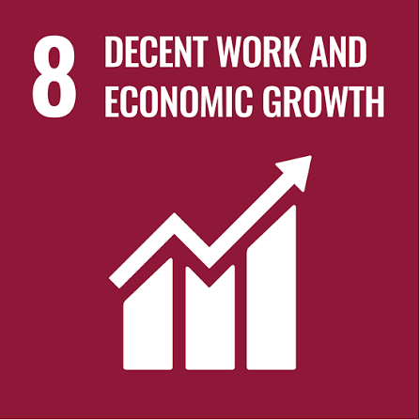 | 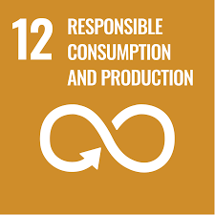 |  |  | 

10. Governance
Board of Directors
Provides overall oversight of supply chain governance, supplier-related risks, responsible sourcing practices, and the effectiveness of this Policy.
Senior Management
Provides leadership, resources, and accountability for implementation of this Policy and ensures that responsible supply chain considerations are integrated into procurement activities, supplier relationships, and business decision-making processes.

Procurement Manager
Leads the implementation of responsible supplier management practices, including supplier selection, screening, evaluation, due diligence, performance monitoring, and engagement. Ensures that relevant supplier requirements are incorporated into procurement processes and contractual arrangements and coordinates appropriate corrective actions for identified supplier risks or non-compliance.
Sustainability Officer
Supports the integration of environmental, social, ethical, and governance considerations into supplier management processes and assists with supplier assessments, monitoring, training, reporting, and continuous improvement initiatives. The Sustainability Officer shall annually review and update this Policy to reflect changes in applicable laws, regulations, Company procedures, procurement practices, supplier requirements, and identified sustainability risks.
Environmental Health & Safety Officer
Supports supplier evaluations, audits, risk assessments, compliance reviews, and performance monitoring relating to environmental, health, safety, and related compliance requirements.
Department Heads & Supervisors
Support the implementation of responsible supply chain requirements within their areas of responsibility, ensure that relevant employees receive appropriate information and training, and promote compliance with supplier management, due diligence, and responsible sourcing requirements.
Employees Involved in Procurement and Supplier Management
Comply with applicable Company policies, procedures, and supplier management requirements; participate in required training; conduct supplier interactions with integrity and fairness; and promptly report supplier-related concerns, risks, or non-compliance.
Suppliers and Business Partners
Are expected to comply with applicable contractual obligations and relevant environmental, labour, human rights, health and safety, ethical, legal, and responsible business conduct requirements established by Solex Energy Limited.
The effectiveness of supplier management and responsible sourcing programmes shall be periodically evaluated through supplier assessments, performance reviews, audits, compliance monitoring, corrective actions, supplier feedback, and other appropriate monitoring mechanisms.

11. Performance Reporting
Solex Energy Limited shall periodically monitor and report the performance of its green sourcing practices to evaluate progress, identify areas for improvement, and support informed decision-making.
11.1 Sourcing Performance
Annual sourcing performance reporting shall cover relevant environmental, social, ethical, and supplier-related indicators, including:
- Compliance with applicable sourcing requirements and the Supplier Code of Conduct.
- Percentage of sustainable or environmentally preferable materials sourced.
- Supplier assessment and performance results.
- Progress on waste reduction, resource efficiency, and other relevant environmental objectives.
- Identified gaps, risks, corrective actions, and improvement measures.
11.2 Internal Audits
Performance shall be periodically reviewed through internal assessments or audits to evaluate the effectiveness of sourcing practices. The review shall cover:
- Compliance with established sourcing processes and requirements.
- Supplier performance and identified areas of concern.
- Status of corrective and improvement actions.
- Progress against defined sourcing and sustainability objectives
11.3 Stakeholder Feedback and Communication
Relevant feedback from employees, suppliers, customers, and other stakeholders shall be considered as part of performance evaluation. Key performance results, significant findings, improvement actions, and relevant changes in sourcing practices may be communicated through appropriate internal reports and sustainability disclosures.

12. Review Mechanism
The Sustainability Officer, in coordination with the Procurement Manager, shall review this Policy at least annually to assess its relevance and effectiveness. The review shall consider supplier performance, assessment and audit findings, compliance status, stakeholder feedback, corrective actions, and emerging supply chain risks.
The Policy shall be updated whenever required to reflect changes in applicable laws, regulations, Company procedures, procurement practices, supplier requirements, or identified environmental, social, ethical, and governance risks. Significant revisions shall be communicated to relevant employees and suppliers, as appropriate.
Revision History
Revision No. | Date | Description of Change
0.0 | 02/01/2025 | Initial issue of the Responsible Supply Chain and Supplier Management Policy.
1.0 | 02/01/2026 | Annual review completed; policy updated to incorporate revised supplier management requirements, regulatory changes, and sustainability risk considerations.

Approved by:

[Name]
Chairman & Managing Director
Solex Energy Limited

13. Employee Acknowledgement
I acknowledge that I have received, read, and understood the Responsible Supply Chain & Supplier Management Policy of Solex Energy Limited. I understand the Company's expectations regarding responsible supplier selection, evaluation, due diligence, monitoring, ethical business practices, and compliance with applicable requirements.
I understand that I am responsible for complying with the Policy and applicable Company procedures when engaging with suppliers and business partners, and for promptly reporting any identified supplier-related risks, concerns, or non-compliance through the designated reporting channels.
I understand that the Policy is reviewed periodically and may be updated to reflect changes in applicable laws, regulations, Company procedures, procurement practices, supplier requirements, or identified risks.
By signing below, I confirm my understanding of and commitment to comply with the applicable requirements of this Policy.

Employee Name: __________________________
Employee ID / Department: __________________________
Acknowledgement Date: __________________________
Employee Signature: __________________________

